Plant Life Observations
Notes on plant observations

Olympic National Park Plant Guide

Sitka Spruce Western Hemlock Western Red Cedar
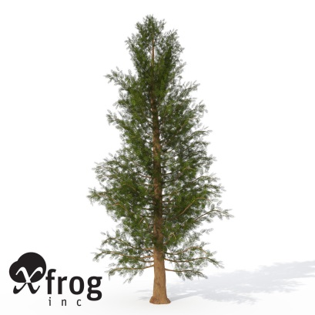
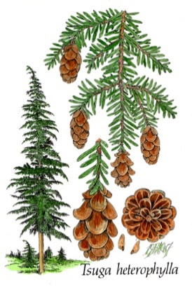
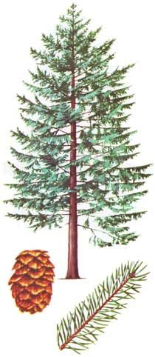

Red Alder Salal Evergreen Huckleberry
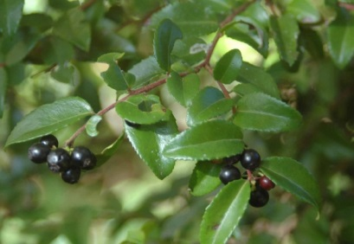
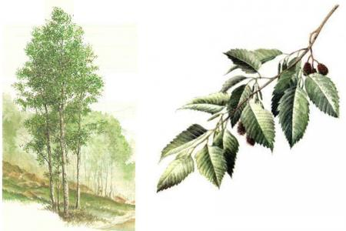
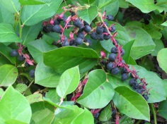

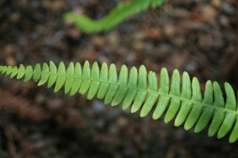
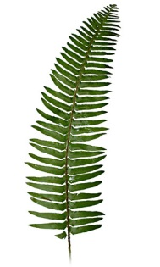
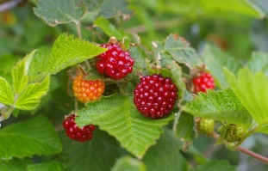
Salmonberry Deer Fern Sword Fern

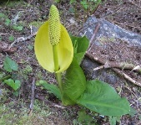
Skunk Cabbage

2nd Grade Comparing writing rubric
 | 1 | 2 | 3 | 4
COS  Content Organization and Style | Writing has less than 2 compare or contrast sentences. Writing is unclear or incomplete. A few vocabulary words are used. | Writing includes 1 -2 compare or contrast sentences but not both or are not complete. Some descriptive vocabulary is used. | Writing includes 4 sentences describing the differences between the Olympic National Park and the school yard. Uses descriptive vocabulary correctly. | Writing includes 5 or more sentences describing the differences between the Olympic National Park and the school yard. Uses descriptive vocabulary correctly.
CON  Conventions Grammar and spelling | A few of the words are spelled correctly and the sentence is missing a capital letter or and end mark. | Some words are spelled correctly and the sentence starts with a capital letter and ends with an end mark. | Most words are spelled correctly and the sentence starts with a capital letter and ends with an end mark | All words are spelled correctly and the sentence starts with a capital letter and ends with an end mark

